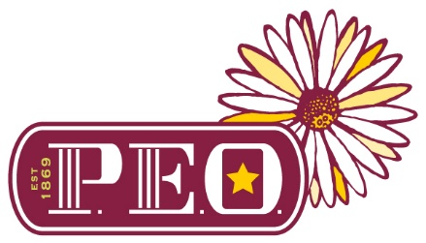
For Immediate Release
May 2021
For more information, contact:
Alice Babb at (515) 555-1234

Shirley and Annie Zhu receive Prestigious P.E.O. STAR Scholarship

Twins Shirley Zhu and Annie Zhu seniors at Houston ISD’s Bellaire High School, were both selected to receive a $2,500 STAR Scholarship from the P.E.O. Sisterhood. Shirley was recommended by P.E.O. Chapter BN and Annie by Chapter HH of Houston, Texas.
Valedictorians Shirley and Annie Zhu created Fresh Hub (https://www.freshhubhouston.com/) to distribute food to low-income residents. They were both national winners of the NCWIT Aspirations in Computing Award as well as involved in many outreach programs including Readiness Across Mathematics, Women in STEM and student council positions. They were also congressional app challenge and art challenge winners. Not only can Annie and Shirley code, but they can also tell a story and create beautiful art.

Shirley will attend Harvard University this fall, pursuing a degree in Computer Science. Her goal is to utilize computer science to build technology that propels social movements and creates sustainable change in communities. This summer she will attend the Google Computer Science Summer Institute.

Annie will attend Stanford to also pursue a degree in Computer Science or Symbolic Systems. Her goal is to challenge the way our structures operate from education to law through the advent of technology.

The P.E.O. STAR Scholarship was established in 2009 to provide scholarships for exceptional high school senior women to attend an accredited postsecondary educational institution in the U.S. or Canada in the next academic year. The competitive STAR Scholarship is for women who exhibit excellence in leadership, academics, extracurricular activities, community service and potential for future success.
Chapter BN has been a part of the Houston community since it was organized in 1947. Chapter HH has been part of the Houston community since it was organized in 1992.
P.E.O. (Philanthropic Educational Organization) has been celebrating women helping women reach for the stars for more than 150 years. Since its inception in 1869, the nonprofit organization has helped more than 116,000* women pursue educational goals by providing over $383 million* in grants, scholarships, awards and loans. The Sisterhood also owns and supports Cottey College. Through membership, the P.E.O. Sisterhood has brought together more than a half a million women in the United States and Canada who are passionate about helping women advance through education, while supporting and motivating them. In addition to the educational philanthropies, the P.E.O. Sisterhood provides a framework of support and community for all members.

What started with a bond of friendship among seven women in Mount Pleasant, Iowa, is now one of the oldest women’s organizations in North America with close to 6,000 chapters. To learn more about P.E.O., its powerful educational philanthropies and see stories of women who have benefited from the programs, visit peointernational.org

You can also join us at:
facebook.com/peointernational
@PEOInternational on Instagram
@PEOSisterhood on Twitter.com

*As of April 2021

###

