I am Karen North, a current classroom teacher in Houston ISD. I would like to thank you for giving me the opportunity to serve on the computer science review committee for the Technology Application TEKS. This is a very positive process for our state. Texas is considered by many states to be the largest and grandest leader in computer science education. We have continued this lead with the development of nine powerful high school courses. K-12 CS education is a critical national need and Texas can take the lead with your detailed review of the each standard.

There is currently legislative action to put computing in the core curriculum and establish planning grants to strengthen K-12 CS Education. Students will be better prepared for the rigor in high school STEM courses, including C&TE and other technology application high school courses, with a foundation in computational thinking. But to strengthen K-8 education the TEKS need computer science concepts at their core. The standards need to include robotics and programming because this lays a foundation for critical thinking skills.

There is no C&TE area for K-8 like there is in high school. To ensure that CS education is part of the solution to enhance rigor and relevance, please consider adding an enrichment area for CSE, Computer Science & Engineering. This gives students the opportunity to create products of learning that can help build the innovative and creative minds for our future. At a minimum, please include specific CS concepts in the K-8 Technology Application TEKS. TEKS enhance the coordination of the standards with the adoption of instructional materials, such as robots and training for the growing free cloud software such as Scratch from MIT, Alice from Carnegie Mellon and Kudo from Microsoft. This must be a standard in the TEKS in order for the resources to be allocated by schools.

Career paths do begin in elementary school. As Virginia Woods, concerned citizen at many SBOE meetings said, this STEM area is essential for our nation; kids are inspired starting in elementary school.
My primarily Hispanic low-income students are capable of being a computer scientist or software engineer. But they must be exposed to this high-tech career path to gain a passion for this field of study. Preparation for the computational sciences and engineering can easily start in Kindergarten. I hope you will find a way to include the software tools of programming languages in the K-8 standards, such as these robots. Children learning how to program these little Bee-Bots is a fun way to introduce critical thinking skills. This will pave the way for students to build engineering and computational thinking minds.

Thank you for your questions and consideration.

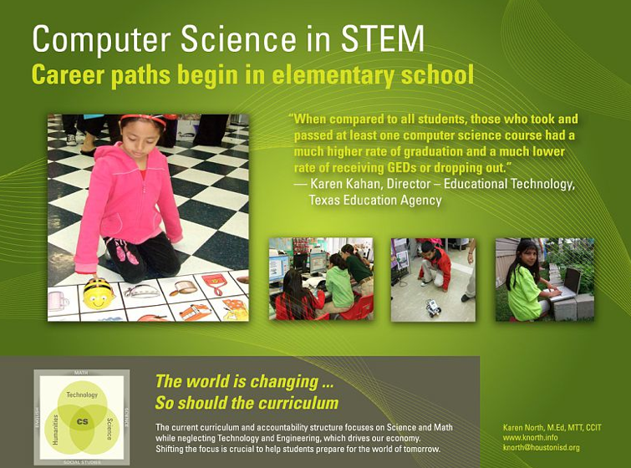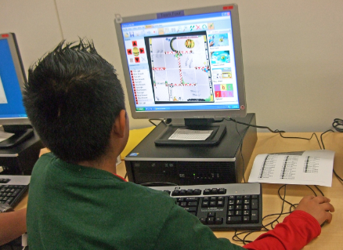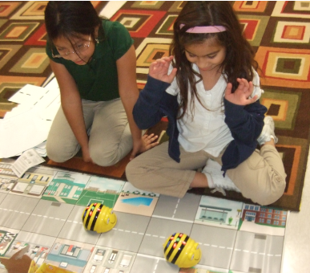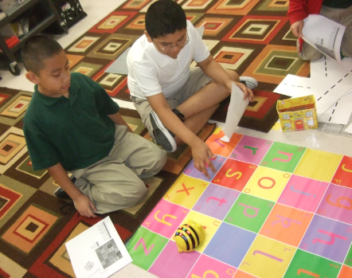

The most powerful of software tools is the programming language...
An important role for the teacher is as a sort of human tool,
A consultant on ways and means, rather than an initiator of activities for students.
Brian Harvey 1980
Logo Programming Language Developer

